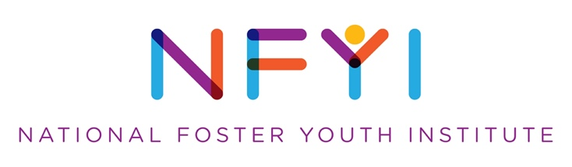
Position: Communications Manager
Job Type: Part-Time Contract
Location: Los Angeles preferred, remote possible
Supervisor: Director of Development
Salary: Negotiable

National Foster Youth Institute
Founded by Congressmember Karen Bass in 2012, NFYI is dedicated to ensuring that current and former foster youth have a seat at the table alongside legislators, policymakers, decision makers, families, and advocates. We believe that truly transformative foster care reform is possible only when individuals who have personally experienced the child welfare system have leadership roles in changing it. NFYI creates pipelines of leadership that connect current and former foster youth with decision makers to change the systems that impact them. We do that by building relationships with members of congress, training and empowering foster youth and families to make their voices heard, and by organizing grassroots support for child welfare reform.

We are at a pivotal moment in our organization’s history as we build on past successes and extend our reach. NFYI seeks an energetic Communications Manager to join our team that will help the organization to achieve even greater impact for foster youth and their families.

Position Description
This contract position will help NFYI increase its visibility, lift up #FosterYouthVoices, develop effective messaging, and reach additional members and donors. The Communications Manager will write and create content, guide the organization in communicating with members/potential members across the country, pitch and place stories/interviews/op-eds, and serve as an NFYI spokesperson. The ideal candidate will be a self-motivated, collaborative professional with proven success in communications and outreach, and a commitment to helping current and former foster youth tell their personal stories to advocate for change in the child welfare system. This position reports to the Development Director and Executive Director.

Essential Duties:
- Oversee and execute all communications intended for public consumption to ensure consistent messaging.
- Manage communications campaigns and content management system.
- Manage and update NFYI’s photo/video library, story bank, and videos.
- Maintain and update social media channels regularly.
- Write copy for and update the website; supervise website vendors.
- Develop and distribute monthly e-newsletters.
- Design fundraising collateral including invites, brochures, sponsorship decks, signage.
- Pitch stories to media outlets, respond to interview requests, and assist members in writing and placing op-eds.
- Maintain and educate staff on branding guidelines.
- Track analytics.
- Other duties as assigned.
Qualifications:
- College degree and a minimum of three years of experience working in a communications role.
- Proven and successful track record of developing communications and outreach.
- Very strong written communication skills for a variety of projects, including solicitation letters, newsletters, social media, email and web communications.
- Attention to detail.
- Eye for design and an ability to create informative and eye-catching graphics, knowledge of design software.
- Ability to build partnerships with funders, organizations, elected officials, and youth.
- Experience and passion for working with young adults.
- Familiarity with/ability to learn content management systems (i.e., Constant Contact) and email marketing software.

This is an opportunity to have a real impact and create real potential for growth. To apply, please submit a cover letter and resume to: jobs@nfyi.org with the subject: Communications Manager.

